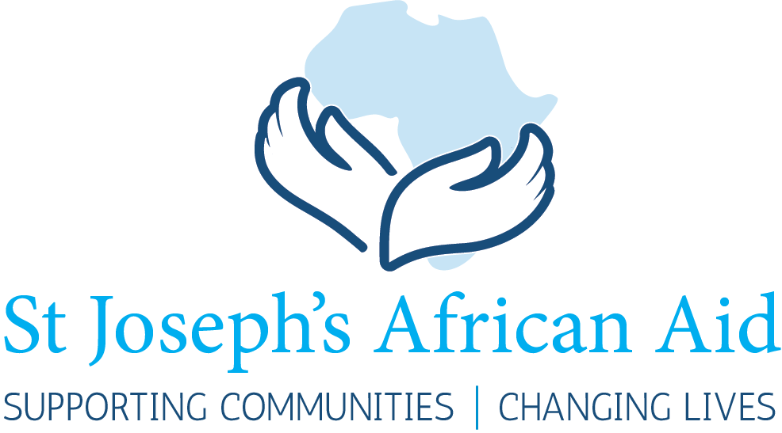

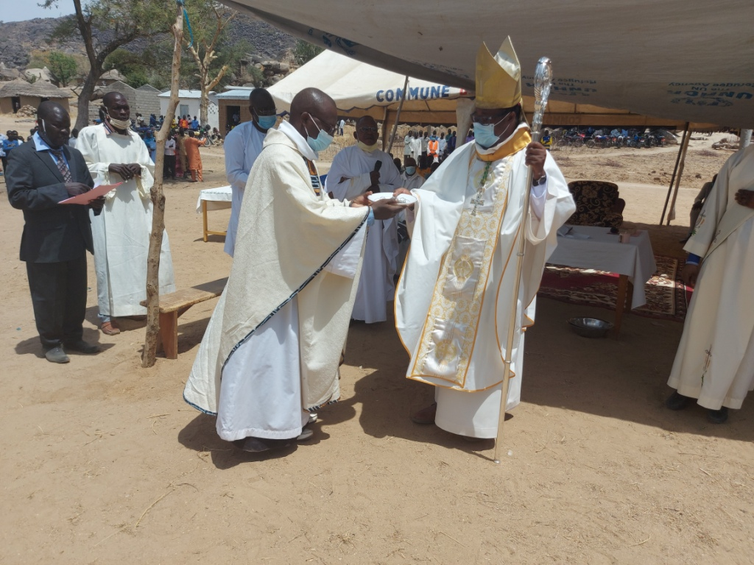

The Bishop of Maroua-Mokolo, Msgr Bruno Ateba Edo SAC, receives the keys to the new Medical Centre.

_{Newsletter 2021}

_{NEWS FROM SJAA}
The Pandemic
The delay in the publication of the 2021 Newsletter has been due to the Covid-9 pandemic. This Newsletter is accompanied by an important message to all donors from the Chairman of SJAA explaining recent developments in the Charity. In spite of the pandemic SJAA has completed a number of projects in Africa.
Completed Projects
Since the last Newsletter SJAA have completed a number of small projects:
Blackboards for schools. SJAA has financed new blackboards in Bulongo
A chainsaw. SJAA has financed a chainsaw for the woodwork school in Bulongo.
Sewing machines. The Lycée Ste Marie in Ilebo (a most successful sewing school) has been able to purchase 169 new sewing machines with money from SJAA.
Laptop computers. St Joseph’s college in Koza (North Cameroon). SJAA has co-funded the purchase of laptop computers for this newly establish college.
Gomembley, North Cameroon
This year’s Newsletter will be devoted to our major project in Gomembley in the North Cameroon; the establishment of a comprehensive Medical Centre there. This medical centre has been established in response to several tragic deaths in Dourum (See following paragraph).
The SJAA Newsletter of 2020 contained a report on this tragic incident
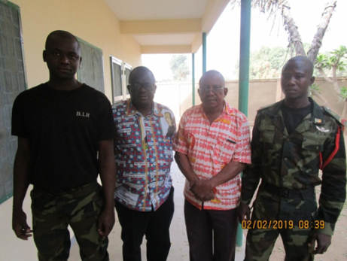
During a recent visit by Fr Jacob Beya, a Trustee of SJAA, to Dourum in the North Cameroon, armed thieves broke into the mission where he was staying during the night. He, and other Josephites, were attacked and robbed. Villagers, hearing the noise of the break in, rushed to the scene of the robbery. Unfortunately in the ensuing confrontation the thieves opened fire. A number of villagers were killed outright and others, wounded, died of their wounds on their way to a remote hospital.

Fr Jacob and Fr Roger with guards.
As a result of this tragedy SJAA agreed to finance the construction of a Medical Centre at Gomembley; a village not far from where the tragedy took place.
Gomembley, making a difference
Today the people of Gomembley have a Medical Centre which is properly furnished and supplied with electricity and water. The running of the centre and the medical staff for the Centre will be the responsibility of the local health authorities.
Not only have the lives of people in the village of Gomembley have been radically changed for the better, the Centre stands as a monument to the brave men who gave their lives for others. May their supreme sacrifice never be forgotten.

Construction of the Medical Centre  The successful construction of the Medical Centre owes a lot to Fr Roger Beya C.J. For information on Fr Roger see below.  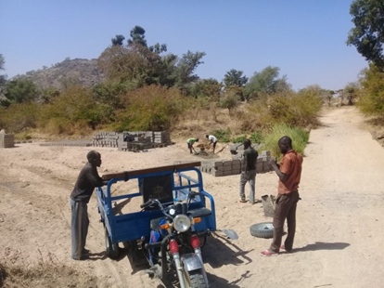  Bricks arrive |  | 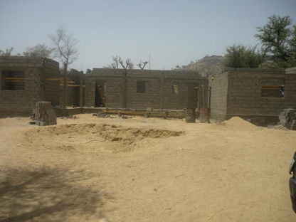  The Centre starts to take shape  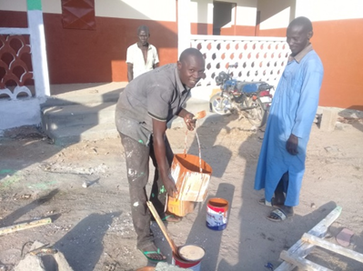  Ready to paint
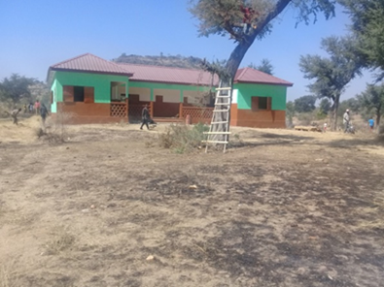  The Medical Centre  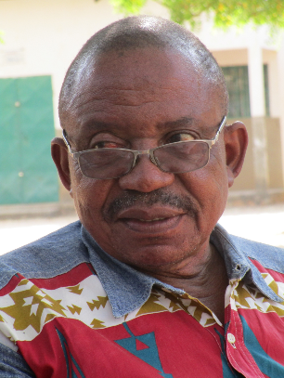  Fr Roger Beya has over the years overseen the construction of 7 SJAA water wells in the North Cameroon. The medical centre is his most recent project. |  | THE CENTRE WILL BE FULLY FURNISHED  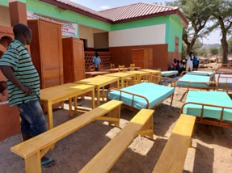  Cupboards, tables, benches and beds  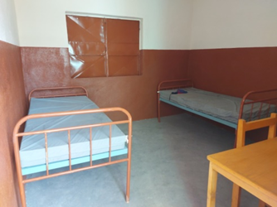
Water  The North Cameroon has a very long dry season. SJAA has already provided water wells and pumps elsewhere. (See Newsletters for 2016, 2017, 2019)  The Medical Centre would not be able to function without a regular supply of clean water.  The underground water table has been found and a well installed. A pump will be fitted and clean water made available for the Centre and the local villagers. |  | 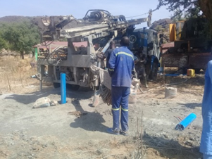  Drilling for water
The Opening Ceremony
The Roman Catholic Bishop of Maroua Mokolo, together with the local head of the village, formally opened the Medical Centre. A great day for the local Muslim and Christian population.
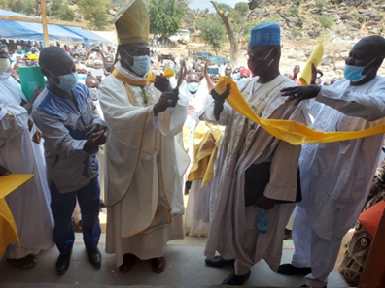 |  | 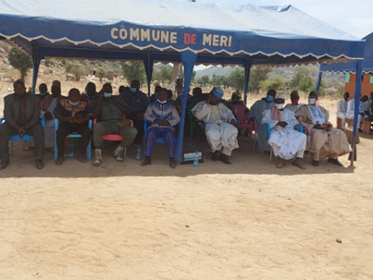  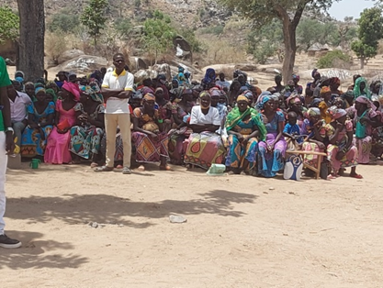
Please help us if you can
Your donations are the foundation of our work.
Every donation, no matter how small, is valuable. Money goes a long way in Africa.
Donations can be sent by post to SJAA at SJAA. Acorn Cottage, 74 Byfleet Road, New Haw, Addlestone, Surrey. KT15 3LB. Donations can also be made online through Virgin Giving.

