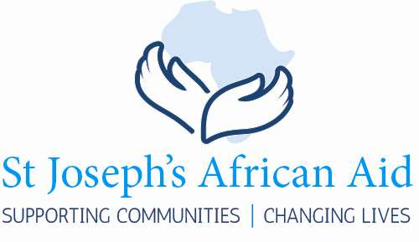

|  |  |  |  |
| --- | --- | --- | --- |
|  |  |  |  |

Newsletter 2018

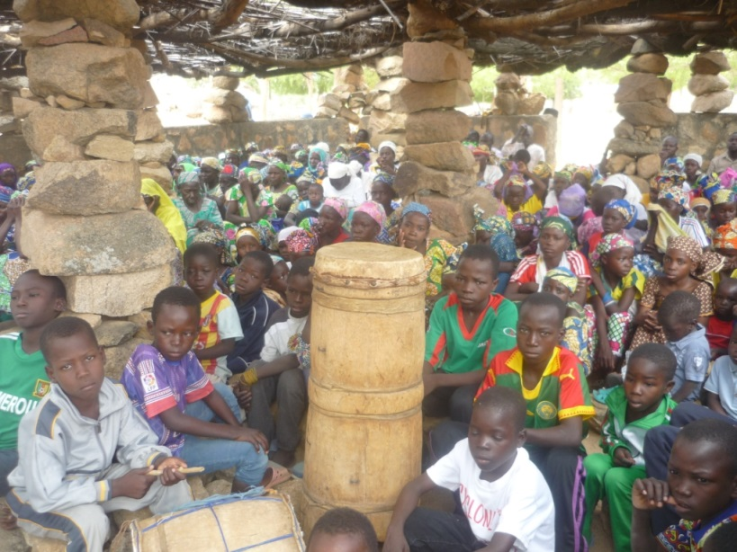

A new logo & strapline.

St Joseph’s African Aid was founded in 2001. At that time we had little idea how the charity would develop. Looking back over the last 16 years we can only marvel at what we together with our donors have achieved. The Trustees decided that the time had come to adopt a logo and a strapline that reflect not only these achievements but also the respectful and supportive style we use in dealing with requests for help. The gentle hands on either side of the African continent reflect the gentleness and respect which is at the heart of SJAA.

Looking back over the years we have supported village communities and educational communities and together with our donors have had the privilege of changing people’s lives.

|  |  |  |
| --- | --- | --- |
| The Trustees  SJAA is a Charitable Trust governed by Trustees. The Trustees meet three times a year. None of the Trustees receive any remuneration for the time and work they devote to SJAA.  All donations received by SJAA are spent on projects in Africa that have been approved by the Trustees. The administrative costs are minimal; the two main expenditures are the Newsletter and the cost of the annual audit. These costs are met by the extra revenue received in Grant Aid.  The Trustees are fully aware of their responsibility to ensure that your money is spent wisely. The Trustees would like to thank all SJAA’s donors for their help and support over many years. |  |  |
| Political unrest in the Congo  The political situation in the D.R. Congo is very tense. The refusal of the President to hold elections has led to violence and even starvation in certain areas. While there has been little coverage of the violence and the consequent starvation in the English Newspapers, reports and photos on the world wide web make clear the grim reality of the situation. For the moment none of the areas in which SJAA is active are directly affected apart from Kinshasa where the violence is only streets away from our school. |  |  |

|  |  |  |  |  |  |
| --- | --- | --- | --- | --- | --- |
|  | |  | Education.  Schools are at the heart of local communities. They bring together parents, teachers and pupils. SJAA from its earliest years has supported schools in the DR Congo and the Cameroon. Classrooms, school desks, text books remain a priority. Lives are changed when young people attend a school where there are proper classrooms and educational materials.  The photo of young children in the Kindergarten in Ilebo sitting outside because they have no classrooms was accompanied by a request for 3 new classrooms for the youngest pupils.  SJAA have now financed ($24,150) the construction of 3 new classrooms for them. The photo shows the classrooms nearing completions. This means that a proper start to their education has been assured. | | |
| Sewing school in Domiongo  SJAA has always been aware of the importance of the education of girls and young women. Education needs to be both vocational and academic. The sewing school in Domiongo has no classrooms of its own and classes are in the parish room which becomes unavailable when there are parish activities. For some years the girls have had to carry their sewing machines to and from class.  SJAA have financed ($24,153) the building of a block of 3 classrooms. | |  |  | | |
|  | |  | Text Books, Domiongo  Frequent changes in the syllabus lead to a constant request for text books. This time SJAA have financed ($8,286) the provision of text books for the Institut Technique et Commerciale in Domiongo. The provision of text books makes learning easier for pupils and teaching easier for teachers. | | |
|  | |  | | |  |
| Gagala, Cameroon: an urgent request  There are times when SJAA needs to reply to an urgent request. While we take a regular supply of water for granted, people in many areas of the world have to search for water on a daily basis. Often it is the women of the village who have to search for water. These photos show better than words the plight of so many women in Africa.  The women of Gagala in the North Cameroon have to walk a great distance to dig for muddy water from dried up streams. Then the water then has to be carried back to the village. Their urgent appeal to SJAA for help could not be ignored.  $15,000 was sent immediately to finance a proper a proper well at Gagala which once installed will transform the lives of these women. | | | | | |
| Every little helps  SJAA is always happy to receive small donations. Money goes a long way in Africa and small donations soon mount up. We have collected used postage stamps over the years. Adrian Cadwallader organises the re-sale of used postage stamps to raise money for SJAA.  Many of the manual sewing machines being carried by the girls in the photo on page 2 were collected in England and sent on to the Congo. | |  | | |  |