St Joseph’s African Aid
Tenth Anniversary
Newsletter
Manual Sewing Machines
Transport - a desperate need
Shortage of Water
Medical Centre - Bulongo
SJAA. Development and aims 2001-2011.

It is now over 10 years since St Joseph's African Aid was established in 2001. This annual Newsletter will look back over the last 10 years as well as looking forward to the years which lie ahead.

Today SJAA strives to be a small but effective Charity.

The last 10 years have seen a gradual evolution in the way SJAA operates.
- We soon abandoned our web site which proved time consuming and costly.
- We have never tried to raise our level of income over and above what we can spend effectively.
- We have avoided any sort of aggressive fund raising campaigns.
- Over the years we have focused our aid more and more on financing educational projects mainly, though not exclusively, in the Territory of Mweka in the Province of the Western Kasai. (You can always look up Mweka on Google earth)

The news from the D.R. Congo printed in the national press emphasizes the horrors that take place there. There is little or no mention of the fact that in many parts of the D.R. Congo life goes on as normal. SJAA continues to function effectively despite the challenges facing the country.

Education, especially the education of girls is vital for the future of the country. The experienced gained through the regular visits to the D.R. Congo by the Chairman of SJAA have led to an ever increasing emphasis on educational projects.

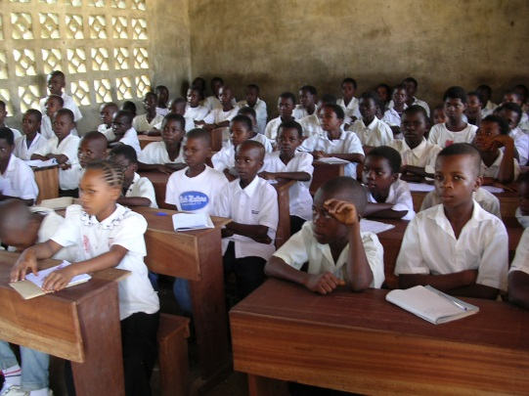

A hope for the future. Ilebo. A class of attentive pupils

SJAA works in close collaboration with the Josephites, a teaching congregation, who have founded 3 schools over the last 10 years and are now responsible for the education of over 1500 boys and girls in the 9 schools which they run. This collaboration enables us to asses the efficacy of our aid and ensure it matches the needs of those responsible for these schools. This collaboration is strengthened by regular visits to the D.R. Congo.

Education. A poignant photo.

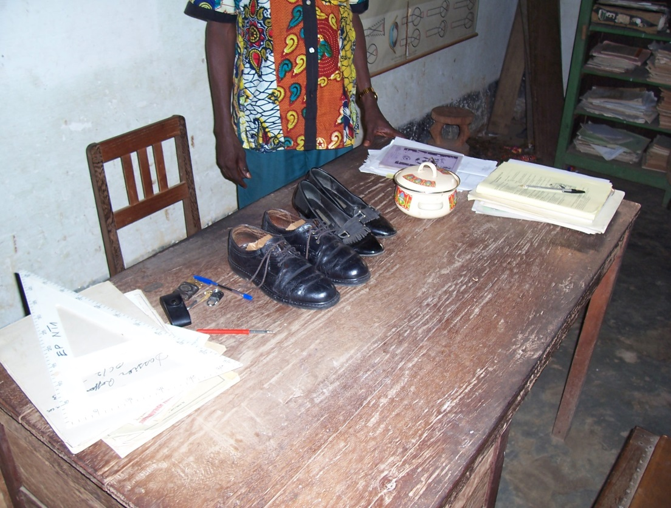
Parents in the D.R. Congo, as in all African countries, do all they can to ensure their children receive at least a basic education.
The burden of paying school fees for a large family of children can often be too much.
During a recent visit to the D.R. Congo the Chairman of SJAA took this photograph of 2 pairs of shoes in the desk in the office of the Headmaster of the primary school in Domiongo. These shoes were presented as payment for school fees by hard up parents.

Over the last 10 years there have been few changes on the Board of Trustees which has enabled us to build up spirit of mutual understanding and a common aim.

SJAA has always adopted the policy that is has a duty to spend our donors' money wisely and effectively and to keep them informed about the projects we are financing.
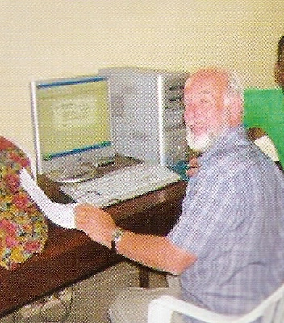
Finance. A few facts and figures.

SJAA has kept a detailed record of its income and expenditure.
This is the work of Neil Twist who is our Financial Director.
When it comes to financial aid SJAA works in U.S. Dollars.

Neil Twist. Number crunching.
We started 10 years ago with a £10 ($15) cheque. Over the last 10 years we have raised over $750,000 in total.
Income fluctuates from year to year but $75,000 per annum is a fair measure of our current income. It is unlikely to remain at this level during the economic down turn.
Over the last 10 years SJAA has made grants approaching $500,000. Of that $500,000 close to $300,000 has been spent in the past 5 years.
Most of the $300,000 has been spent in the DRC (90%) but there have also been a couple of projects in the Gabon.
Of that total expenditure in the past 5 years, 75% has been spent on education, 8% on pastoral care/formation, 8% on transport, 7% on community projects and 2% on healthcare.
Within the 75% spent on education, a quarter of this has been spent on buildings and the same amount on teachers’ salaries. The remaining half has been spread fairly evenly over books, desks, sewing machines etc.
No single project has been particularly large. No single grant so far has exceeded about $30,000.

Teachers.

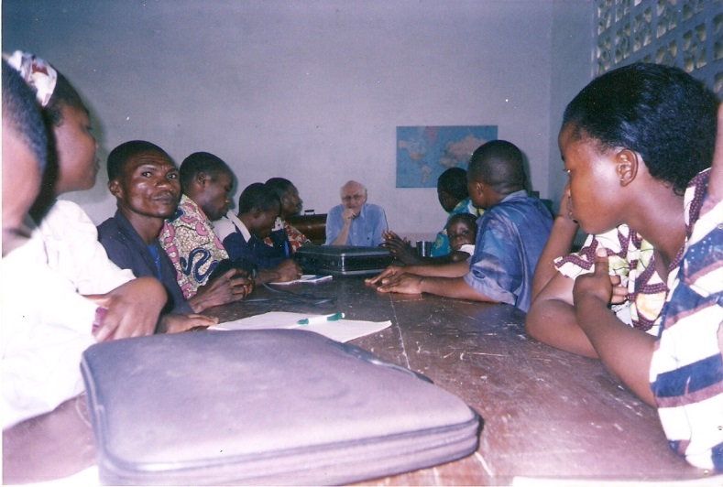

There can be no education with teachers. Our teachers in the Kasai are poorly paid. ($20-$30 per month). They are not paid during school holidays and their salaries are not paid on a regular basis.

The Chairman of SJAA meeting with teachers in Ilebo.

For many years teachers at St George’s College & St George’s College Junior School have been making monthly donations by deduction from their salaries to help their colleagues in the Kasai.
On average 65 teachers at SGC & SGCJS make regular annual donations. This enables SJAA to send between $15,000 - $20,000 each year to the teachers in our Kasai schools.
Once again this year 120 teachers in those Kasai schools will receive $140 each.
This is a marvellous example of people in the same profession but on different continents helping one another.

The fact that the exam results in our schools this year have been excellent is a direct result of the financial support and encouragement our teachers receive.

Educational projects. 2001-2011
Here are some of the important educational projects made possible by your generosity.

A laboratory for St Etienne. Kinshasa.
SJAA equipped a new science laboratory with the help of the Debenham Trust.
This new laboratory with its excellent facilities has been an important factor in the success of pupils studying Physics, Chemistry and Biology.
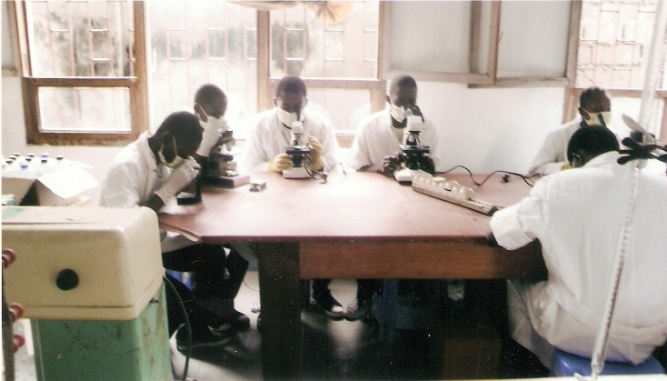
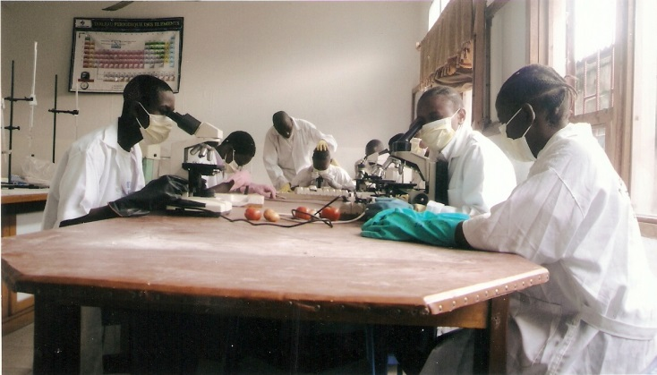
Pupils hard at work in their new laboratory in St Etienne’s College Kinshasa.

St. Jacques primary school.
SJAA helped to transform an old church into a Primary School. SJAA helped to ensure that there were desks, blackboards and texts books in the new school.

Today St Jacques Primary School is flourishing and offers children an excellent education from their earliest years. French is spoken in the school from day 1 and the little ones soon become good French speakers. An ability to speak good French is their passport to a good job and the opportunity to enter higher education in the years to come.

A little anecdote.

In July 1970 the present Chairman of SJAA was living in Ilebo. Every day he had to turn away youngsters who wanted to enroll in the local school. They were unable to do so because there were not enough places in the school.
What a joy it was to visit St Jacques nearly 40 years later and see so many happy pupils.

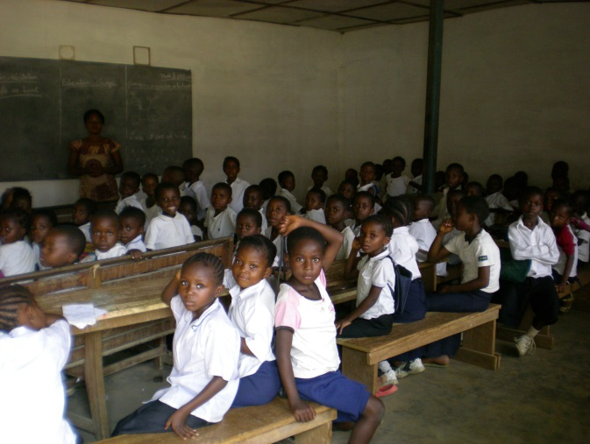
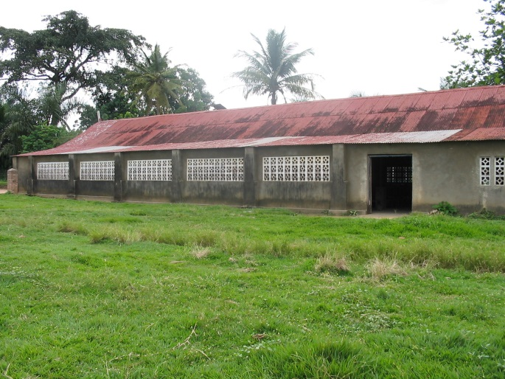

The former church. A class room in the new Primary School

Part of the old church has also been transformed into a Kindergarten called Marie La Berceuse and it is wonderful to see the youngest children at work and at play.

As everyone knows the first few years in education can be crucial for a child’s future academic career. How many future doctors and scientists etc. may be found in the photo of the group of tiny tots below?

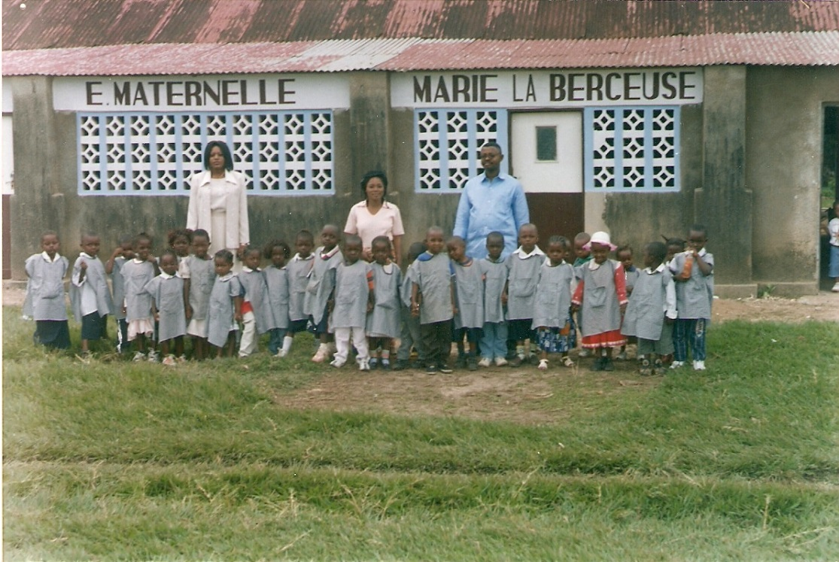

The Reception Class
These little ones are able to make an excellent start to their education.
Equipment for Mushenge.
SJAA has now successfully completed the project mentioned in last year’s Newsletter. The art school in Mushenge has been re-equipped.
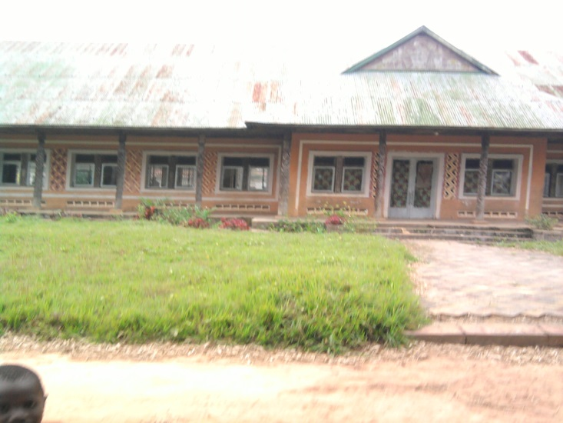

SJAA sent money to purchase equipment for the art school in Mushenge. This school specializes in training pupils in the traditional wood carving skills of the region.

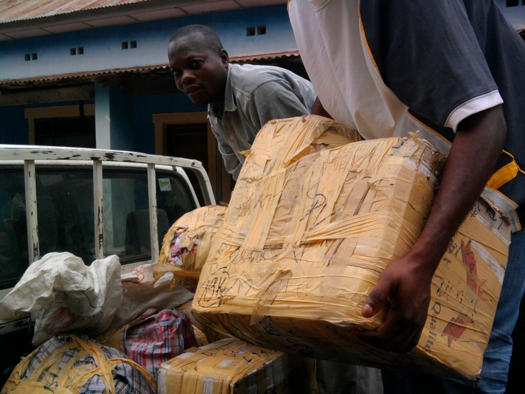
The art school. Mushenge.

The equipment was bought in Kinshasa and then shipped to Ilebo. From there it was delivered by truck to Mushenge. This was a difficult exercise on account of the state of the roads. Mushenge is a little off the beaten track.
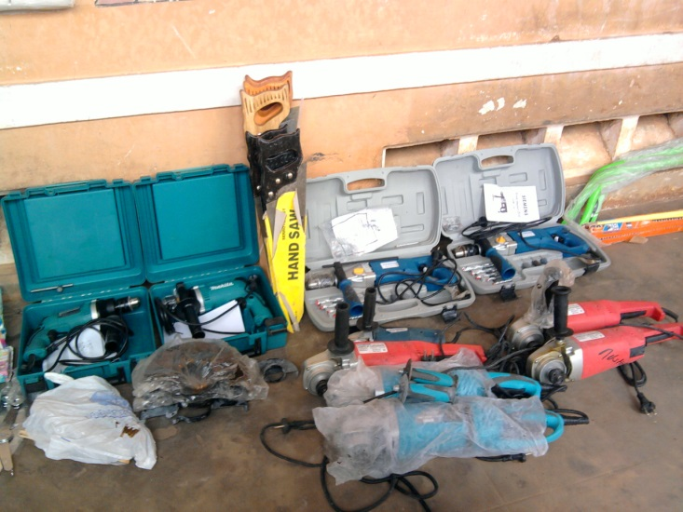

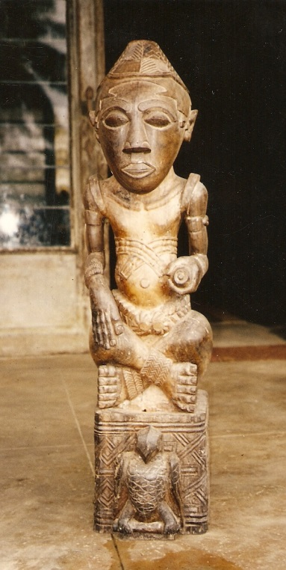

A traditional wooden statue.

Some of the equipment delivered to the Art School.

Technical Schools. (Ilebo. Domiongo. Bulongo)

These 3 schools offer young people the opportunity of an academic education while at the same time acquiring a practical skill. SJAA supports these schools.

The woodwork school in Bulongo.

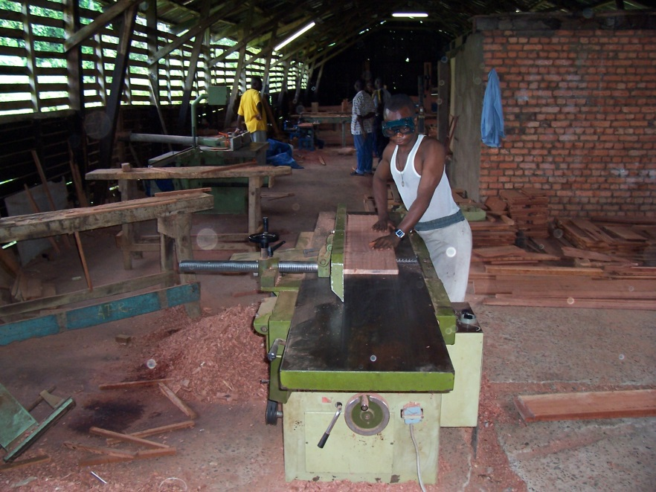

The woodwork shop in Bulongo.

SJAA has financed the purchase of some equipment.

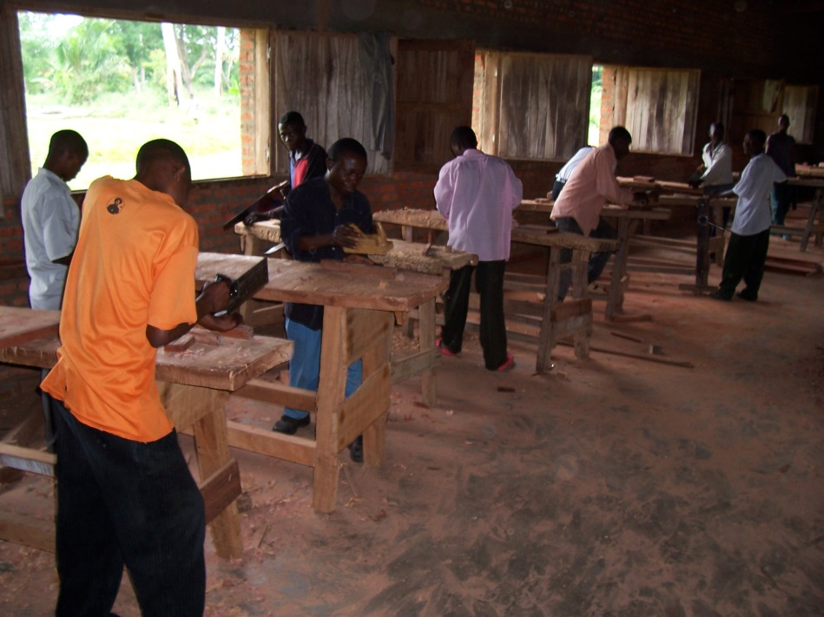

A future project will be to
Provide money for the purchase of a box of tools so that pupils leaving the school will have the equipment they need to ply their trade.

A carpentry class.

SJAA supports two Dressmaking schools in the Kasai, one in Ilebo and the other in Domiongo.
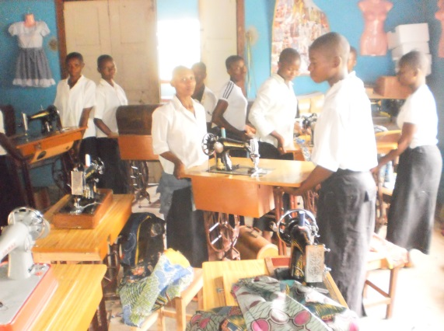
These dress making schools are very important. They offer girls the opportunity of an academic education together with a practical skill.

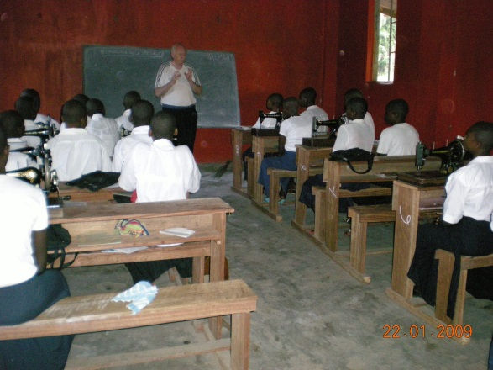

A dress making class
Rydes Hill Preparatory School funds bursaries for 15 girls in the dress making school, Lycée Ste Marie, in Ilebo

Chairman of SJAA talking to class

The Medical centre in Bulongo.
SJAA re-established a defunct medical Centre in Bulongo.
Money from SJAA paid for the refurbishment of the centre and for the purchase of medicines and equipment.

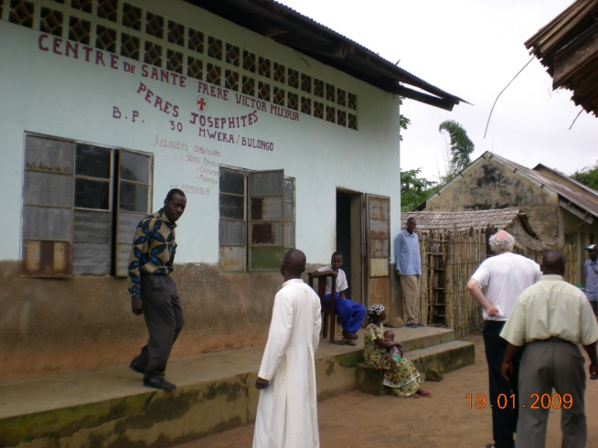
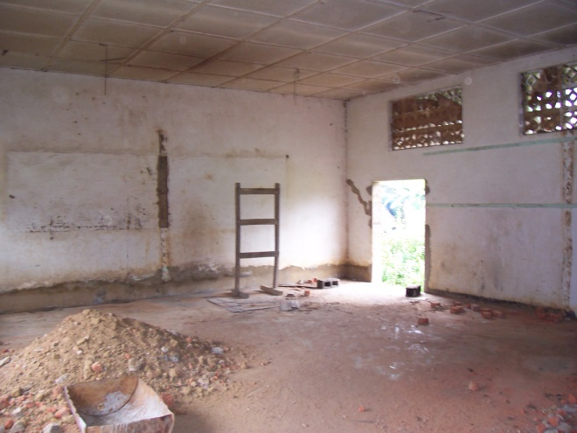

Refurbishing the medical Centre SJAA Chairman visiting
the Centre in 2009.

The medical centre at Bulongo provides an essential back up for the staff and the boarders at St Joseph’s College. It is also available to the local population.

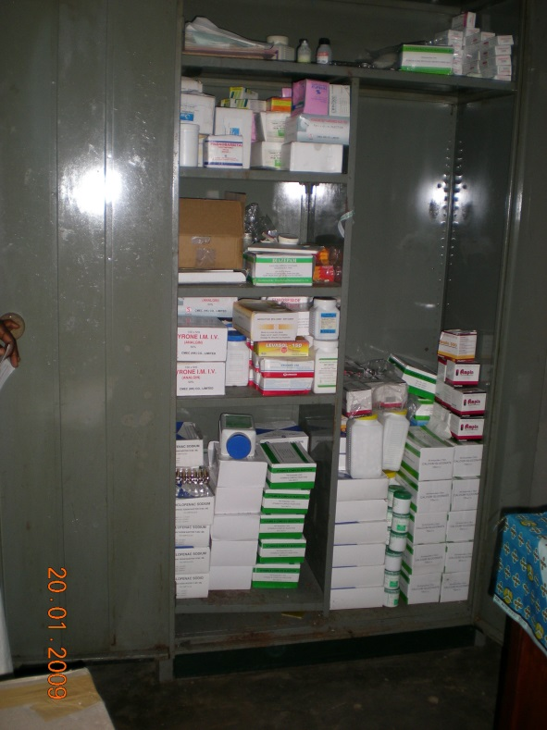
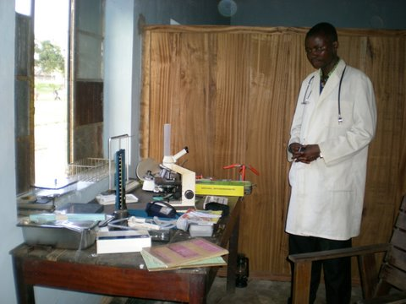

Medical equipment.

The Doctor is a former pupil of St Joseph’s
College.

Medical supplies
School equipment.

Schools need equipping. SJAA have helped to finance the equipping of schools with text books, desks, sewing machines, equipment for the wood work shop.

Sewing machines.

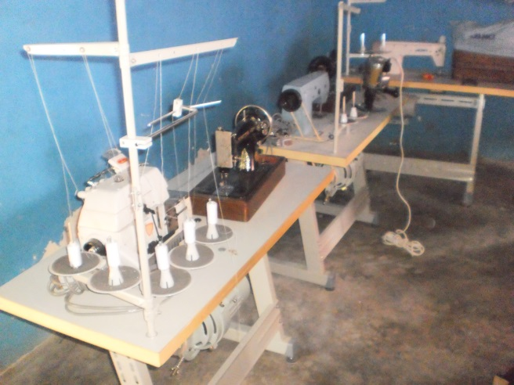
Girls carrying newly delivered sewing machines. Sewing Machines purchased by SJAA

School desks.
School desk are something we take for granted. In the Congo school desks are often lacking in the class room. 8 years ago the Chairman visited the secondary school in Domiongo and was horrified to find some pupils sitting on the floor because there were not enough desks. This lack of desks has long since been rectified.
However, the shortage of desks in Primary schools remains a serious challenge.

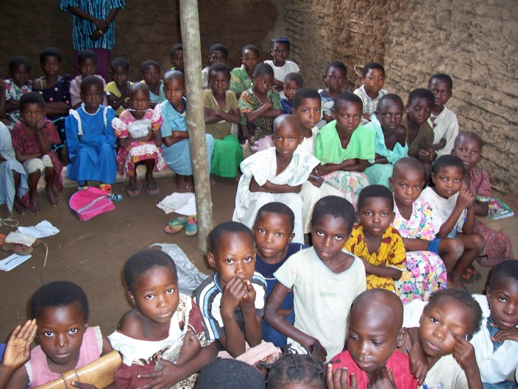
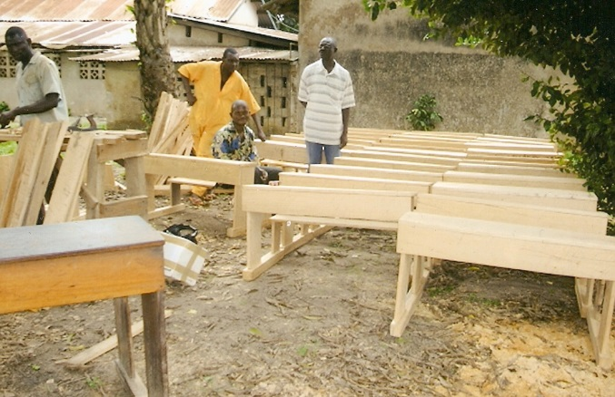

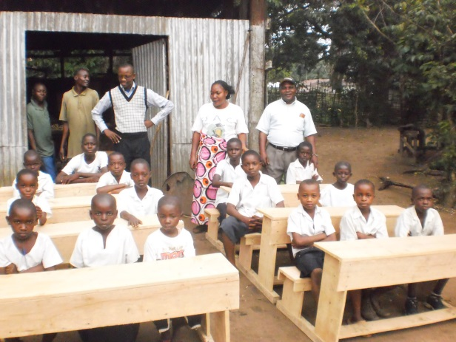
SJAA is financing the manufacture of desks for primary schools.

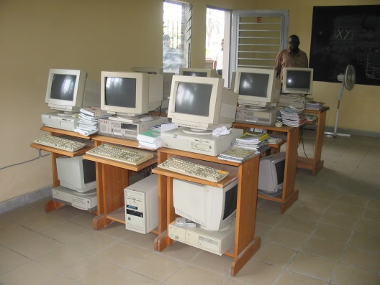

Computers.

Jacob Beya, a member of the SJAA Board of trustees admired the new IT class room in St Etienne’s Kinshasa.

St George’s College has sent computers via SJAA to Kinshasa.

Text Books.
Text books are another rarity in schools in the Kasai.
SJAA have sent money for the purchase of text books.
Chalk and talk still remains the usual method of teaching in the class room.

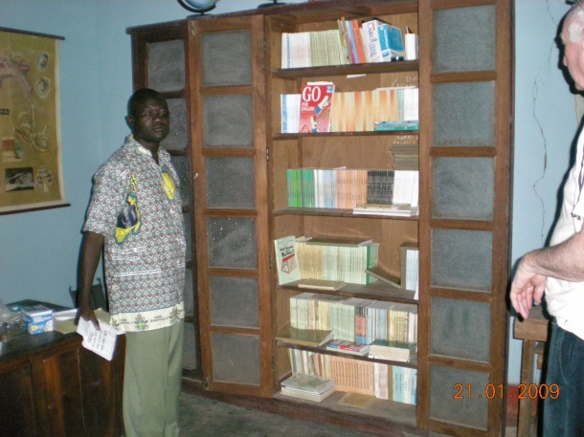
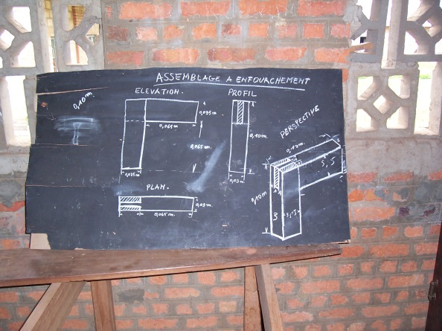

Chalk and talk in a woodwork class. Inspecting the new text books.

Transport.
Travelling in the Kasai is very difficult and the roads are non existent or in a poor state of repair. SJAA has funded the purchase of motorcycles which make possible helped travels along the damaged roads and footpaths.
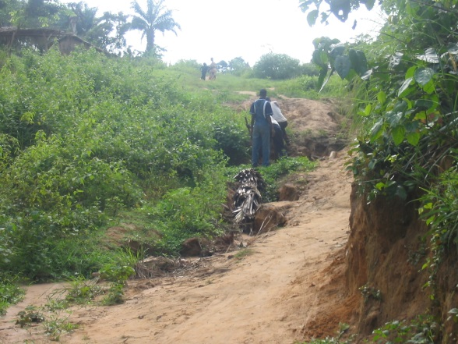

The road. Stuck in a ravine.
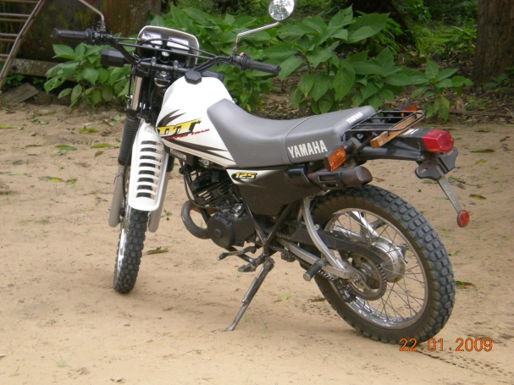
The most practical way of travelling along the pathways is by motorbike. SJAA have financed the purchase of motorbikes for the Kasai.

It is our hope that this brief look at what SJAA has achieved over the last 10 years will help you to understand just what marvels have been achieved thanks to your donations.
Thank you is hardly sufficient to express our deepest gratitude for the way in which you have empowered us to make a difference.

St Joseph’s African Aid. 131 Horton Road. Staines TW19 6AF

