

St Joseph’s African Aid

Charity No 1087768

Registered Office: 131 Horton Road Staines TW19 6AF

Correspondence address: 131 Horton Road, Staines TW19 6AF

*Fr Robert Hamilton*

*Trustee & Chairman*

NEWSLETTER

January 2013.

Dear Friends and supporters of St Joseph’s African aid

Thank you for your support in 2012. I hope this Newsletter will bring you up to date with some of our achievements which have been made possible as a result of your generosity.

Education.

The education of young people in the D.R. Congo is essential to the future development of the country.

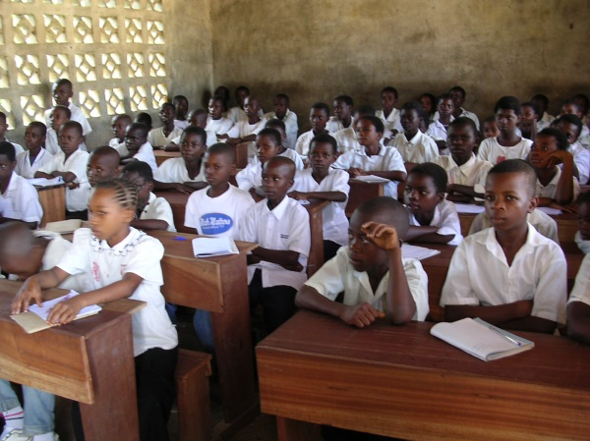

Supporting the education of young people remains the chief concern of SJAA.

We are in close contact with 8 schools in the D.R. Congo 7 of them in the Kasai. This close contact enables us to monitor the effectiveness of our aid. By limiting our aid to a small group of schools it is possible to make a real contribution to their development.

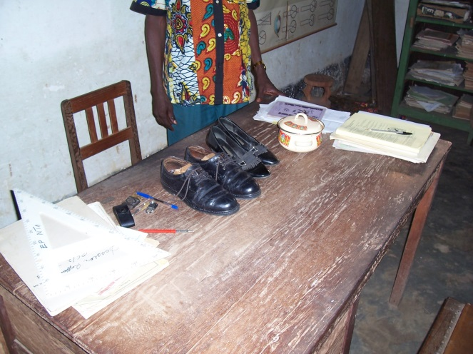 *A class in Ilebo.Kasai.*

Parents make great sacrifices to try and ensure their children get an education. This photo which has appeared before in an SJAA Newsletter is a poignant reminder of the efforts parents make to pay for the education of their children. The pairs of shoes and the cook pot are in lieu of school fees*.*

*Shoes for school fees. Domiongo*

For a number of years SJAA has made serious efforts to help to improve the facilities in schools especially in the Kasai.

New class rooms.

In 2012 we were able to build three new class rooms for the Dressmaking School in Ilebo.

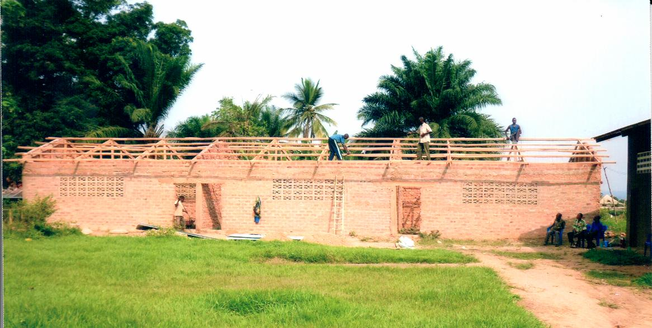The education of girls has always been a priority for SJAA.

The Lycée Sainte Marie in Ilebo offers the usual academic curriculum together with formation in dress making skills.

*The new classrooms under construction*

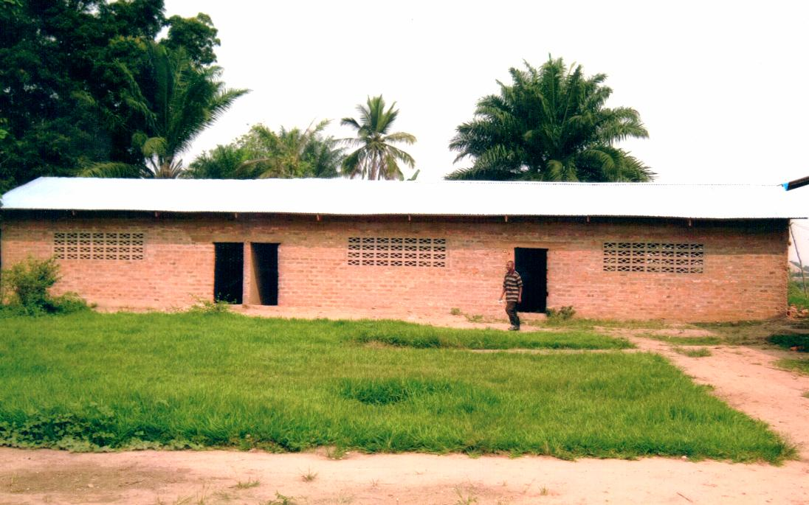

The new classrooms have been equipped with new desks.

SJAA provided the finance for 60 desks for 2 of the new classrooms.

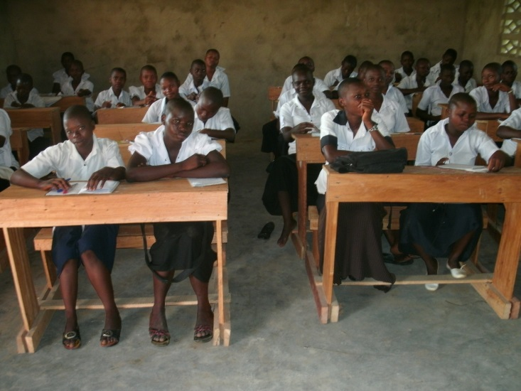

*3 new class rooms.*

SJAA aim to build another block of 3 class rooms in Ilebo.

The Lycée Ste Marie benefits from annual donation of £1000 for scholarships for girls from Rydes Hill Preparatory school for Girls. SJAA are very grateful to the school governors for their support.

School desks.

It is difficult for us to imagine class rooms without school desks. In the past even in a secondary schools there were pupils sitting on the floor because of a shortage of desks. For over 10 years SJAA has sought to remedy the situation by sending money for the manufacture of desks. The provision of school desks is an on-going project.

Recently the school desks have been manufactured in Ilebo; large desks for secondary school pupils and smaller desks for the primary school children.

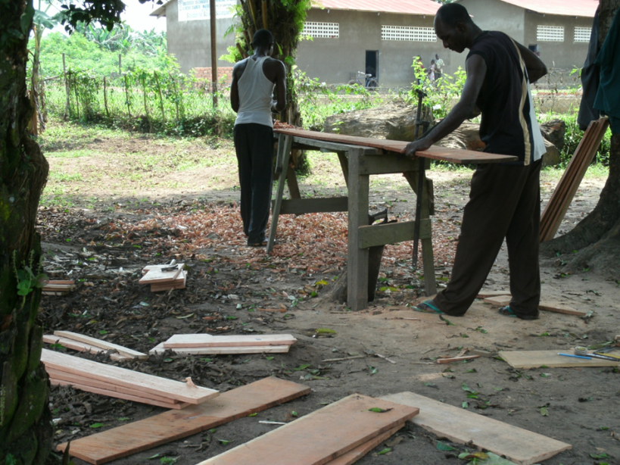This photo was taken in Ilebo.

Work has started on making desks for the Primary School in Domiongo. Because of the expense involved in transporting a large number of desks by train, the component parts of the desks were sent to Domiongo where they were assembled.

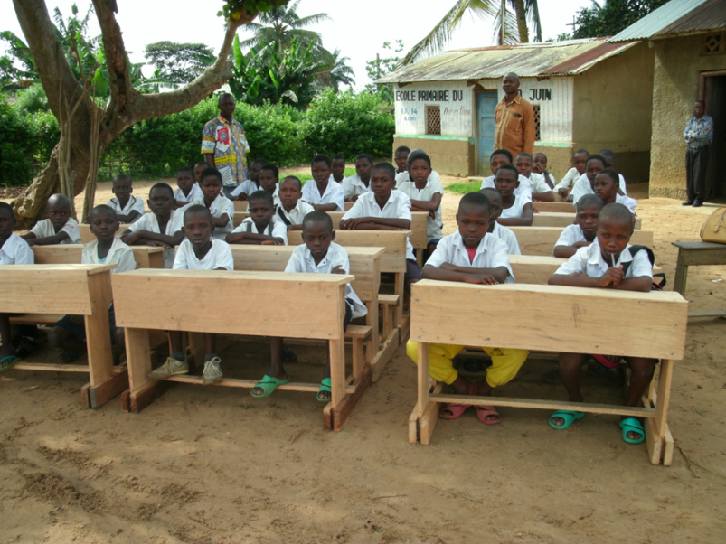

Here is another photo of the brand new desks which have just been made for the large state primary school (Ecole Primaire 30 juin) in Ilebo.

The 30th of June is Independence Day in the D.R. Congo. The desks have been made so that children of primary school age can sit comfortably in them.

Laboratories.

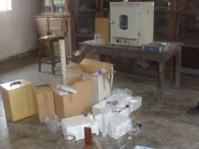The equipment of the science laboratory in St Joseph’s College, Bulongo, is a project which has taken well over a year to complete. The equipment was purchased in Kinshasa but then had to be transferred to Bulongo in the Kasai.

Laboratory equipment is fragile and finding a safe and secure way of transporting it to the interior was no easy task. Eventually the equipment was taken by road.

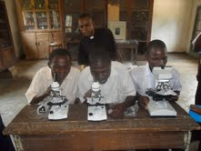

Fr. Quentin, Headmaster of S. Joseph’s College, Bulongo, looks on as some pupils test out their new microscopes.

This new equipment for the science laboratory will be an enormous encouragement for staff and pupils alike.

Financial report. (Year to 31 May 2012)

Donations received amounted to £ 41,745 (2011 £52,816).

Grants made amounted to £61,396 (2011 £35,553).

We are grateful to all our donors for their continued support in times of financial hardship.

We are especially grateful to St George’s College, Weybridge, (governors, staff, pupils and their parents) for their generosity.