

St Joseph’s African Aid

Charity No 1087768

Registered Office: 131 Horton Road Staines TW19 6AF

Correspondence address: 131 Horton Road Staines TW19 6AF

*Fr Robert Hamilton*

*Trustee & Chairman*

**SJAA Newsletter.**

**January 2014.**

The beginning of a new year is an appropriate moment to look back over the past year and report to our donors on the ways in which they have enabled us to make a difference to the lives of ordinary people in Africa.

This Newsletter is largely concerned with women in Africa, south of the Sahara .

One of the aims of SJAA has been the education of girls and the promotion of women in Africa.

**The Mofu women of the North Cameroon.**

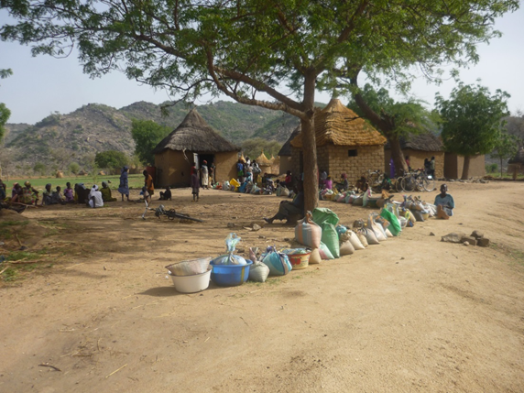

Often the women of the Mofu tribe who live in the mountainous area of the North Cameroon have to travel long distances not only to obtain water but also to visit a local mill in order to grind their Millet and Sorghum into flour.

On arriving at the mill the women sit in the shade while their crops are lined up in an orderly fashion waiting to be milled.

The mills are run by a committee of women who take it in turn to supervise its operation. They take the money and supervise the work of the Miller. If you look closely you can see the supervisor at the doorway of the mill.

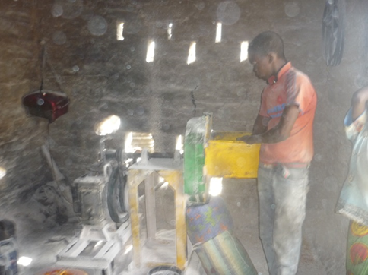

Inside the mill the Miller is using a dilapidated machine. However it works and sack by sack the cereals are milled and the flour taken home by its owner.

Unfortunately the photo only shows part of the woman who is supervising. Her job is to ensure that all the millet or sorghum is milled and there is no stealing.

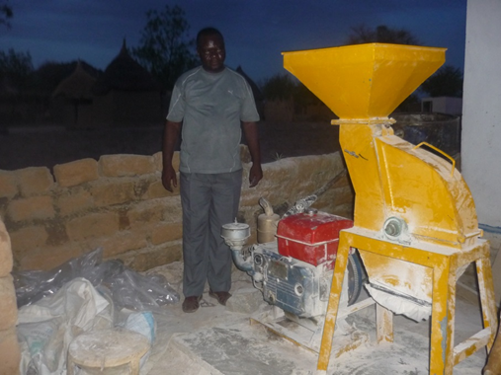The Miller will be paid by the supervisor.

The rest of the money is administered by the

committee of women. They purchase fuel for the machine and pay for repairs etc.

SJAA has sent money to the North Cameroon for the purchase of 2 new milling machines. sto replace mills which are worn out by new ones as shown in the picture.

If the project is successful more mills could be purchased to further reduce the distances that some women have to travel to get their crops milled.

**Sewing machines for the Gabon.**

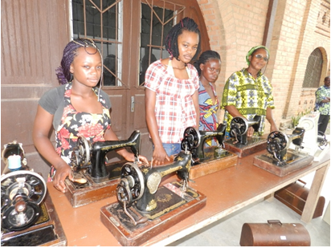For many years SJAA has collected manual sewing machines (mostly “Singer” machines) for use in Dress making schools in the D.R. Congo. Recently some of these machines have been sent to Koulou Moutu in the Gabon. The despatch of a motor car to the Gabon provided the opportunity to fill it with 9 sewing machines.

No sooner had these machines arrived than they were put to good use. A Formation Centre providing training in dress making skills was established. At the moment the centre is providing a professional formation for 4 young unmarried mothers as well as some 5 other women who will use their newly acquired skills to support their family.

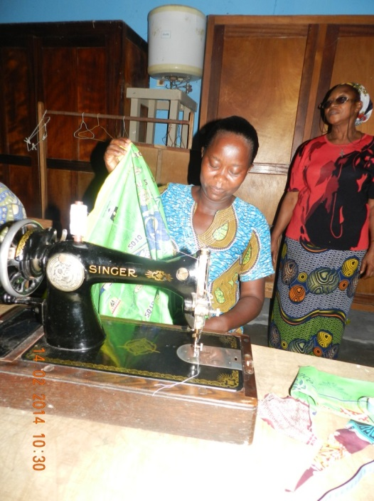The centre is run by the Josephites in collaboration with the local community of Religious Sisters. In the photos you will see Sister Monique proving instruction and help.

Sr. Monique is sister of the Congregation of the Immaculate Conception.

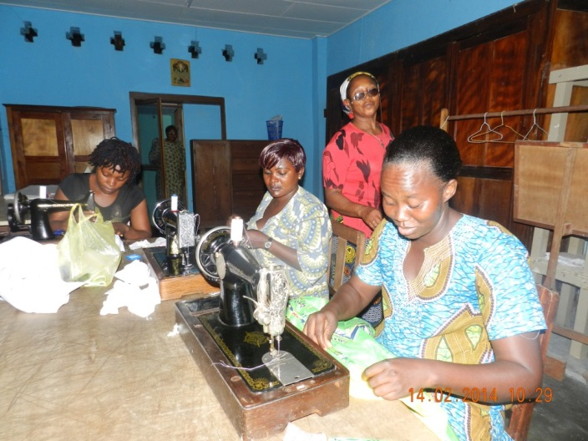

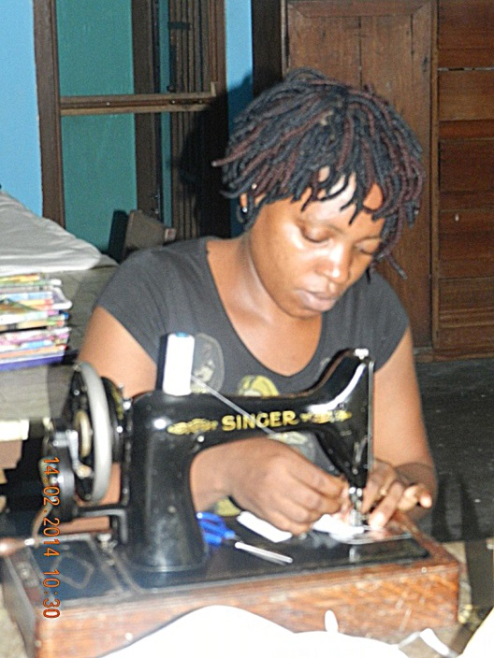

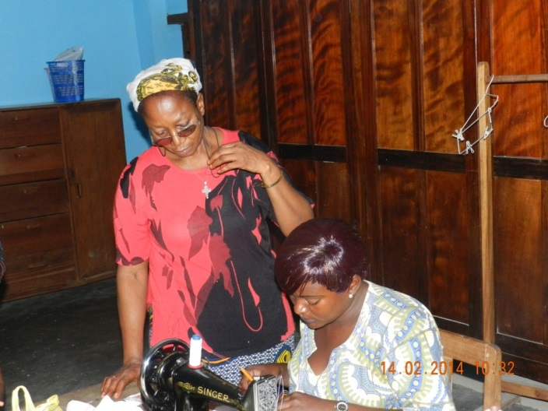

SJAA hope to find ways to support this venture in the future.

Visits to Africa.

The Trustees strive to keep themselves informed at first-hand about the needs of local population at first hand.

Jacob Beya visited the Gabon and the Cameroon in the autumn of 2012 and the D.R. Congo in September 2013. Robert Hamilton visited Kinshasa in January 2014. A further visit to the D.R. Congo by a Trustee is being planned.

SJAA financial report

SJAA’s financial year starts in June.

(1 June 2013 – 30th January 2014)

Donations are £21,790 so far.

Grants made so far total £20,300 made up of:

D.R.Congo.

Kasai Schools – Educational supplies ($600x8) 4,800

Kasai Teachers – Salary augmentation 21,140

Local costs re the above 60

$26,000

Cameroon

Purchase and installation of 2 mills for Douroum Euro 3,000

Like all Charities in these times of economic hardship, donations to SJAA continue to decline. It seems likely that income for 2014 will not reach the sum of £43,196 raised in 2013. However, SJAA has always been prudent in making grants and is in a position to envisage some important projects in the near future. A project of long standing which awaits fulfilment is the building of boarding accommodation for girls in Domiongo in the Western Kasai. Obtaining funds is only the first step. Assuring that the local expertise exists to construct a suitable building is not so easy.

In these difficult economic times we are more grateful than ever to all our donors for their continued support and their confidence in SJAA. We are especially grateful to the governors, staff, pupils and parents of St George’s College, Weybridge; for their generosity. St Mary’s Preparatory School, Rydes Hill continues to provide bursaries for girls in the Western Kasai.

The Trustees continue to make every effort to ensure that your donations are put to good use and meet the urgent needs of local populations.

Education.

Education of young people as well as adults has remained a chief priority of SJAA over the last 13 years.

SJAA continues to support 8 schools in the Western Kasai which educate some 1157 boys and 1169 girls.

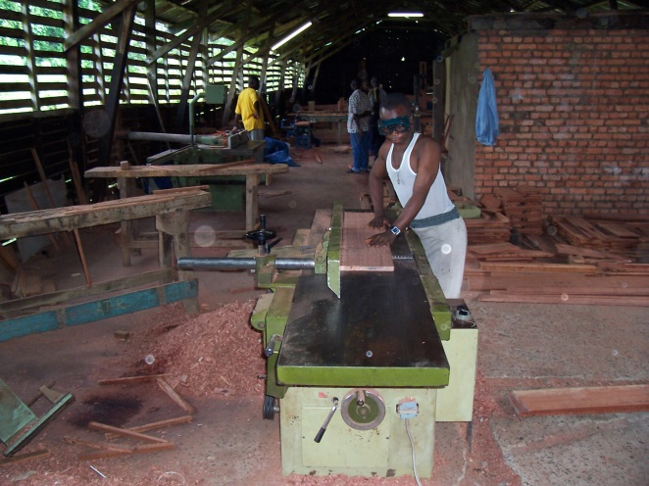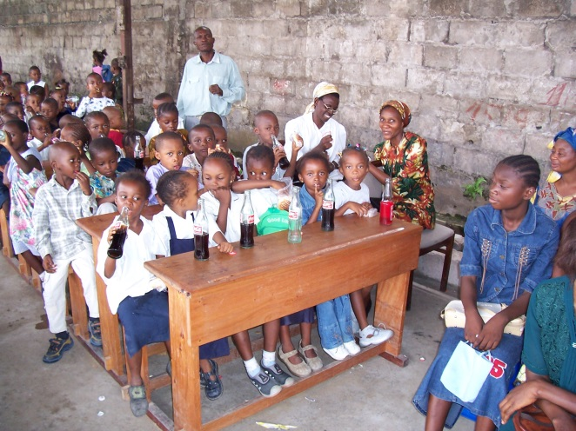

The workshop in the woodwork school. Domiongo Little ones in Kinshasa.

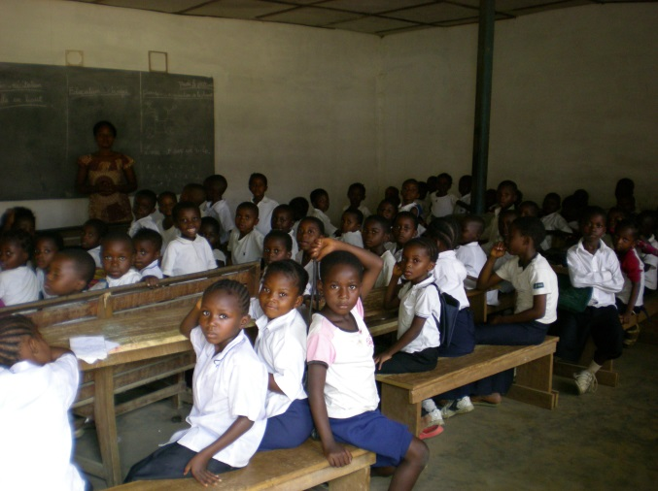

In so many parts of Africa young boys and girls desperately want to go to school and get an education.

Here are some of the lucky ones.

SJAA continue to provide desks and equipment for school in the D.R. Congo.

Thank you for your help.

A Primary School in Ilebo.