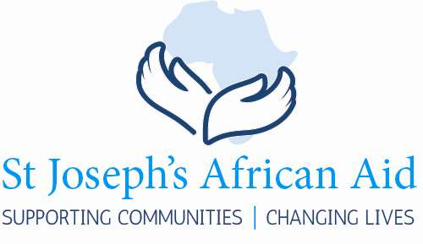

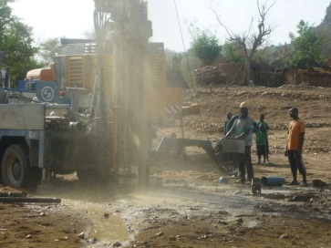 | 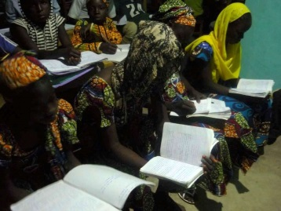 | 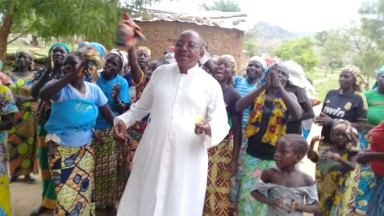 | 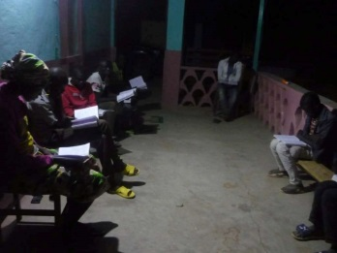

_{Newsletter 2019}

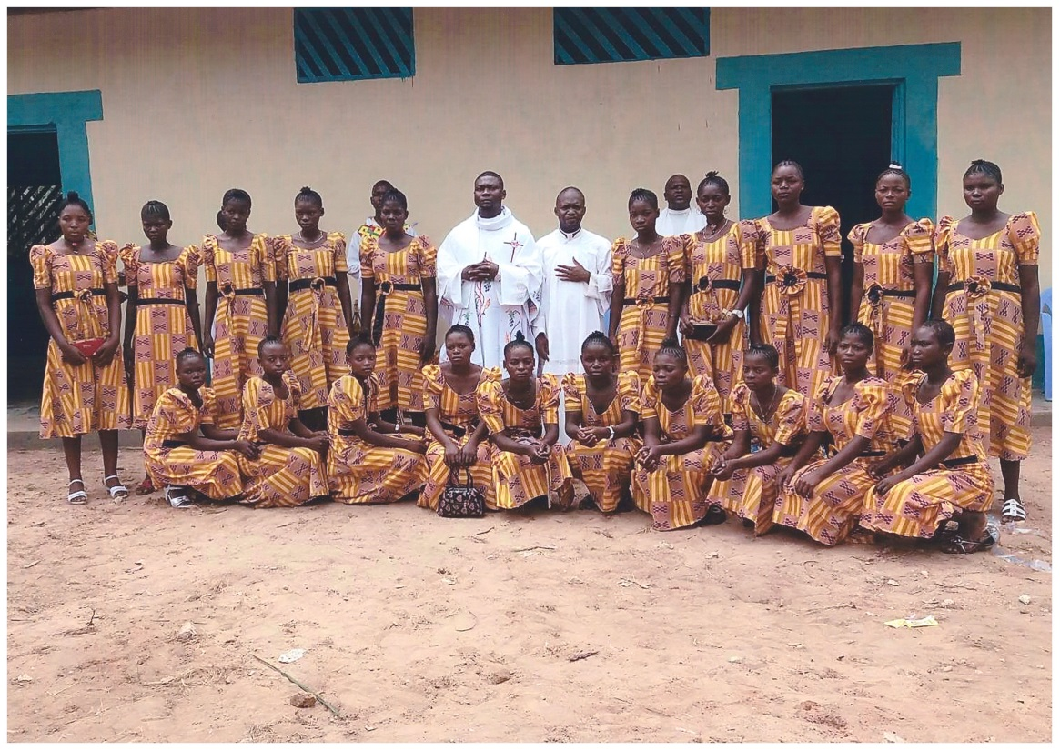

Completed projects 2018.
During 2018 SJAA, thanks to the generosity of our donors, has been able to support local communities and change lives. The list of completed projects might at first sight appear unspectacular. The provision of classrooms, school desks and text books enables young boys and girls to get a real start in life. The provision of water wells transforms the lives of women in the villages.
CAMEROON
3 motor bikes for Roua Parish.
Water well for the village of Gagala
Church roof at Gagala
Solar Panels for Douroum
D.R. CONGO - ILEBO
Classroom block (3 classrooms) for Kindergarten with desks.
D.R. CONGO - DOMIONGO
Text books for new syllabus.
Classroom block (3 classrooms) for sewing school + new desks
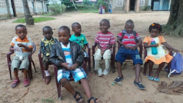  Before |  | 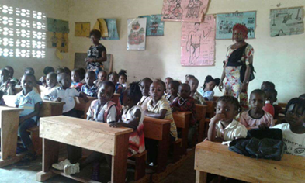  After
Kindergarten Marie Berceuse, Ilebo.
Photographs often speak louder than words. This is often true for the Trustees of SJAA when it comes to deciding on which projects to finance. The photo of small children sitting outside for lessons was received in 2018 and prompted SJAA to build a block of classrooms to meet the ever increasing demand for places. Thanks to the generosity of our donors these kindergarten children sit in their own classrooms in new desks adapted to their size.

A tragic Incident  During a recent visit by Jacob Beya, a Trustee of SJAA, to Dourum in the North Cameroon, armed thieves broke into the mission where he was staying during the night. He, and other Josephites, were attacked and robbed. Villagers, hearing the noise of the break in rushed out to the scene of the robbery. Unfortunately in the ensuing confrontation the thieves opened fire. A number of villagers were wounded and three were on their way to a remote hospital but died of their wounds before reaching it. |  | 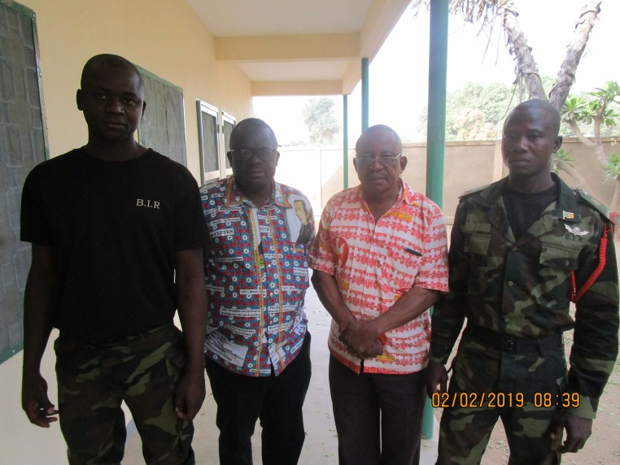  Fr Jacob & Fr Roger with military bodyguards
Solar Panels in Douroum  When the sun sets in the North Cameroon there is no electric lighting to dispel the darkness of the night. School children are unable to study in the evening. SJAA has financed the installation of solar panels in the Mission and school which enables children to continue their studies after dark.  . 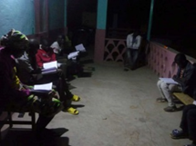 |  | 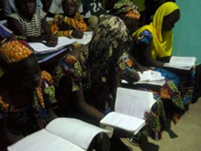  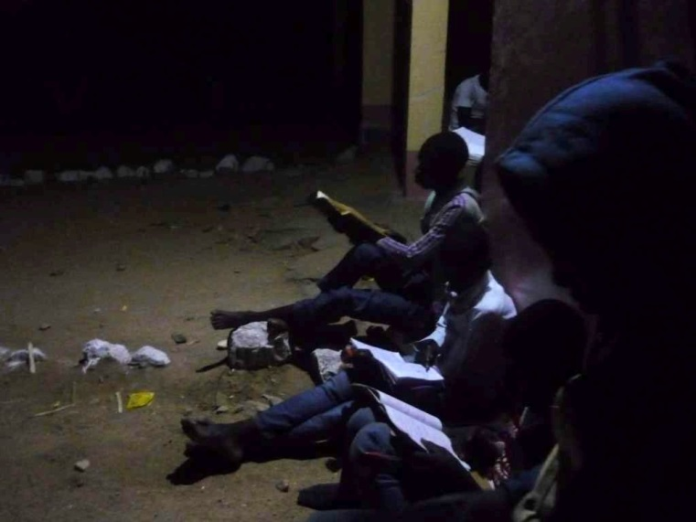

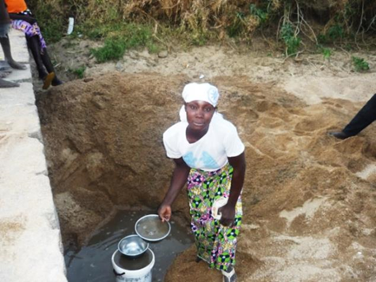  How it was done before |  |  | 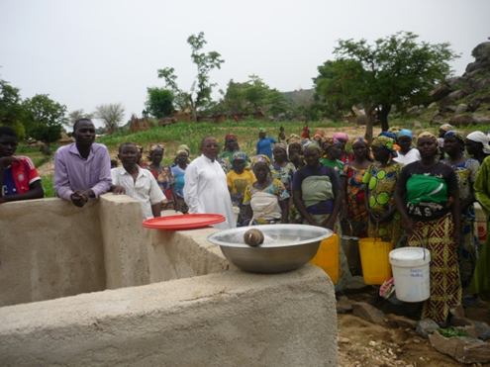  The New Well
Gagala, Cameroon: an urgent request
Last year’s Newsletter contained an urgent appeal by the women of the village of Gagala in the North Cameroon. During the lengthy dry season they are forced to dig in the dried up river beds to find water. As promised, SJAA responded immediately. The women now have their own well and their everyday lives have been transformed.
Sewing school in Domiongo  Last year SJAA responded to a request to build classrooms for the sewing school in Domiongo. SJAA has always been aware of the importance of the education of girls and young women. Education needs to be both vocational and academic. Our photo shows the young women standing proudly in front of their new school wearing the uniform dresses they have recently made. They love to wear a uniform; a sign of their togetherness and their pride in the new school. |  |  | 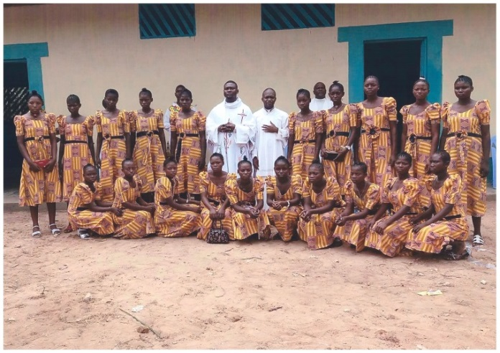  Thank You, SJAA
General Data Protection Regulation
We keep records of your personal details such as name, address, details of donations made, gift aid declarations etc. so that we can manage the charity and we retain these records whilst the charity remains active. Apart from completing Gift Aid claims to H.M. Revenue and Customs we do not share your personal details with anyone else. If you wish to unsubscribe from receiving the Newsletter or other communication from us please contact webmaster@sjaa.org.uk or write to St Joseph’s African Aid at 131 Horton Road, Staines, TW19 6AF

